Prof. Lydia Jane G.

Design Document

Online bookmarking application

**Contents**

1. Purpose
2. Design Outline
   1. Client Server Model
   2. Components of the System
   3. Component Diagram
   4. Architecture Diagram
3. Design Issues
   1. Functional Issues
   2. Non-Functional Issues
4. Design Details
   1. Class Diagram
   2. Sequence Diagram
   3. Activity Diagram
5. **Purpose**

With the online book marking application one can store bookmarks online which can be accessed from any internet enabled computer system through a browser. User can manage, retrieve and classify their bookmarks interactively. The purpose of our application is to solve the issue of remembering various websites, which can now be saved online. Also to give user flexibly to use their stored bookmarks virtually from any system.

1. **Design Outline**

**2.1 Client Server Model:**

Server

Client

The application will be stored on servers but the user will access through client, where he can perform all the operations through a user interface, like saving a bookmark, managing them, adding categories and classifying all the data. On the other hand, all the information (user details, bookmarks, etc.) will be actually stored on the server.

When a user performs any operation such as adding a new bookmark or deleting a bookmark, he directly access his data on the servers through the client where the application is running. In case of adding a new bookmark, the user generates a request to the client to add a new bookmark, which the client executes and sends the data to the server to store it on that particular user’s directory.

**2.2 Components of the System**

1. User Registration
2. User Login
3. Add and Manage Bookmarks
4. Database Access System

**2.3 Component Diagram**

Create_auth_details

User Details

User Registration

Bookmark area

delete

edit

add

Login to account

**v**

User Login

Add & Manage

Bookmarks

Bookmark details

User Details

Database Access System

**User Registration:-**

This component registers new users to the cross platform application. It takes its user details such as name, last name, email id and contact number and each user creates authorization details i.e. Username and Password to access their account.

**User Login:-**

The user login component is for those who have already registered for the applications to help with the problem of bookmarks. The login will take them into the bookmark area where they can view and manage their bookmarks. The bookmarks can be categorized by the user himself.

**Add & Manage Bookmarks:-**

This component is the heart of the application as this is where the purpose is really fulfilled. The Bookmark Manager lets user to ad, edit and delete bookmarks not only individually but also categorically. This is as simple as it gets for the user.

**Database Access System:-**

The database stores all the details of the user and its bookmarks. The data is stored in the form of objects where each user is an object with their details and the bookmarks they can manage through bookmark manager.

The **User Registration** component interacts with the **User Login** component to let the new user login to his bookmark area. The user login is for new and returning users. Through bookmark area, **bookmark manager** comes into picture which helps user manage each bookmark by editing, adding, deleting and categorizing bookmarks. The **database** stores all the relevant details of the user.

**2.4 Architecture Diagram:**

The following diagram depicts the high level specification of the system.

Internet

Bookmarks saved by category

Bookmarks saved by category

Bookmarks saved by category

Bookmarks saved by category

**The diagram shows how over the internet clients via registering on the application can save their required purpose.**

1. **Design Issues:**

**3.1 Functional Issues:**

* The application won’t be able to have the iFrame feature we thought of as sites like google, facebook, gmail etc. don’t allow it.

**3.2 Non-Functional issues:**

* The Application won’t work without internet.

1. **Design Details**

**4.1 Class Diagram**

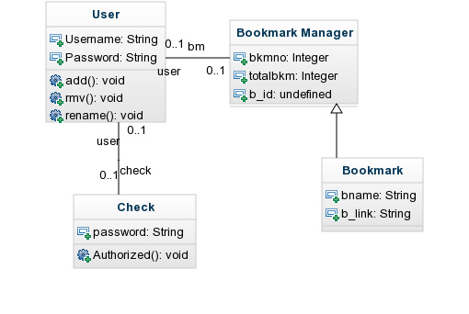

**Class User:-**

User class maintains details of the user, its username, password and a user has the following functions:-

1. Add a Bookmark
2. Delete a Bookmark
3. Rename a Bookmark

The following functions have to be taken care of by the Bookmark manager on the request of the user.

**Class Check:-**

This class is for authorization of username and password of a particular user. While logging in to the system the user has to produce correct username and password combination to access his/her saved bookmarks. This provides authentication of the software.

**Class Bookmark Manager:-**

The Bookmark manager is the interface between user and the software. It manages all the bookmarks by id of each user which is generated automatically. Bookmark manager makes the changes on request of the user. The Bookmark manager is the base class of bookmark. The Bookmark manager stores the number of bookmarks of each user and a number of each bookmark by which the bookmark is identified. The bookmark details are in Bookmark class

**Class Bookmark:-**

The Bookmark class stores bookmark name and bookmark link and the category in which the bookmark lies. This maintains the bookmark database and thus if any changes occur it should reflect in the bookmark class too.

**4.2 Sequence Diagram**

**Registration:-**

Web Interface

Enter Details

Create Username & Password

Confirmation

**Login:-**

Authenticate user

Enter username & password

Web Interface

Bookmarks Area

**Adding a bookmark:-**

Bookmark details

Add Bookmark

Web Interface

Login

Bookmark added to area

**Deleting a bookmark:-**

Delete Bookmark

Select Bookmark

Web Interface

Login

Bookmark deleted

**Renaming a bookmark:-**

Bookmark updation

Select Bookmark

Web Interface

Login

Bookmark edited

**4.3 Activity Diagram**

Registered?

Register

no

yes

Ask details

Bookmarks

added

manage

add

Delete/lookup

login